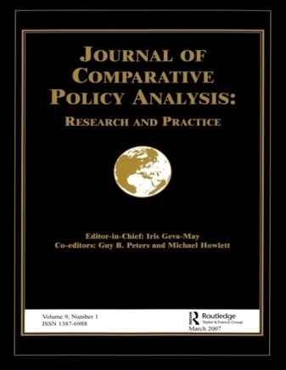 | Call for Proposals: 5th NASPAA & ICPA-Forum/JCPA Workshop  2024 NASPAA Annual Conference, Washington, DC  Workshop Date: Wednesday, October 23, 2024

Co-convenors:
Susan Appe
University at Albany, SUNY
Albany, New York, USA

Sean McCandless
The University of Texas at Dallas
Richardson, Texas, USA

Invited discussant:
David Campbell
Binghamton University, SUNY
Binghamton, New York, USA

NASPAA and the International Comparative Policy Analysis Forum (ICPA-Forum) will co-host a conference workshop during the 2024 NASPAA Annual Conference in Washington, D.C. The workshop (~11am-4pm) will be held on Wednesday, October 23, 2024. Refreshments and lunch will be provided.

Do your classes systematically compare and teach students how to engage in comparative analysis—whether of issues, programs, agencies, levels, branches, types of government, and countries—in the field of public affairs? Building on past NASPAA & ICPA-Forum/JCPA Workshops, first conceived and spearheaded by Professor Nadia Rubaii, we will convene to consider the ways in which effective governance in the public and nonprofit sectors demand a comparative perspective, especially to evaluate how and why similarities and differences in contexts, cultures, leadership, management, structures, and more matter demands an awareness of how things are similar and different in other places, and how to systematically apply a comparative perspective. We adopt a “big tent” approach to explore and assess how comparative lenses are being applied and used in our MPA and MPP curricula, including:

- strategies to examine global perspectives in public governance
- implementation and monitoring of the United Nations’ Sustainable Development Goals (SDGs)
- ways in which to advance SDG 16 specifically and global issues related to inclusion;
- means in which policymakers mitigate misinformation;
- budgeting practices across jurisdictions regardless of level of government and sector;
- how public spaces and monuments are negotiation and contested;
- the design, delivery and/or evaluation of policies or programs of cities, states, or nations, or nonprofits and other nonstate actors, as well as across rural, urban and suburban communities;
- how countries and communities have addressed issues of truth seeking, apologies and/or reparations for historic injustices of colonial invasion, slavery or other forms of mass violence;
- civil society organizations and philanthropy’s responsiveness in the funding and provision of public goods and services;
- approaches to reforms in immigration policy, health policy, environmental policy, criminal justice policy or other specific policy areas; and
- many other important, relevant topics that call on our public service imperative and warrant comparative approaches.
Are you interested in writing a paper about your teaching experiences, and getting in-depth feedback from peers to better prepare the paper for publication? Interested participants are asked to submit proposals centered on detailing successful courses (whether prior or ongoing) and/or assignments (e.g., (e.g., simulations, experiential learning, cases, projects, etc.) that adopt comparative perspectives. Up to five proposals will be accepted for the workshop. Those accepted will be required to submit a draft paper in advance of the workshop according to the format and guidelines for the Comparative Policy Instruction, Syllabi and Pedagogy section of the Journal of Comparative Policy Analysis (JCPA). At the workshop, participants will present their papers, share materials (syllabi, simulations, cases), and receive extensive feedback from the other participants and the workshop co-conveners. Participants agree to serve as discussants on other submissions as part of the interactive workshop format.
The submissions will also be reviewed by a committee consisting of representatives of both NASPAA and the ICPA Forum, and the winner will receive an award of $500 at the NASPAA conference. The winning paper will also receive expedited review for consideration by the Journal of Comparative Policy Analysis in conformance with guidelines for the comparative syllabus section (see https://comparativepolicy.org/special-sections-jcpa/).
Important Key Dates
August 1, 2024 - Proposal submission deadline to co-conveners (550 words max)
Questions and proposal submissions should be directed to Susan Appe at sappe@albany.edu

August 10, 2024 - Notification of accepted proposals
October 1, 2024 - Draft of paper and workshop registration deadline; papers made available to
participants

October 23, 2024 – Conference workshop, all participants are to have reviewed the papers and
discussants will provide formal written and oral feedback to their assigned paper, 11am-4pm (exact time to be confirmed).

Workshop Registration Information: The workshop includes refreshments and lunch. The workshop fee for all participants (presenters, discussants and other attendees) is $56 for students, $66 for faculty at institutions that are members in good standing of the ICPA Forum, and $76 for faculty from other institutions. The fee includes membership to the ICPA-Forum and all related benefits as well as a FREE annual subscription to the Journal of Comparative Policy Analysis.

