NASPAA Data Policy
November 30, 2011
Revised: October 2016

Purpose
NASPAA is the authoritative source for data in public affairs education. As part of being the authoritative source for data in public affairs education, NASPAA is committed to collecting, analyzing, and managing data from member schools. Doing so allows NASPAA to: promote the culture of data-driven approaches to program accountability and effectiveness; address the data needs of prospective students seeking information about member schools; and serve member schools by publicly promoting them to prospective students through NASPAA’s school search and public profiles. NASPAA seeks to serve the general public by providing accurate and timely data about the discipline. The stakeholders for this effort include: schools, students, relevant professional associations (higher education and professional), the general public (including prospective students), and the media.
Ownership

NASPAA follows these general principles in regard to data ownership:
- The data submitted to NASPAA are public data or are owned by the schools that collect them or the individuals providing their personal data.
- Schools will provide data to NASPAA for use consistent with this policy. By placing data in the NASPAA Data Center, schools represent that they are authorized to provide the data and create increased value from aggregation of data from member schools.
- Where school-related data include students, employees, or other individuals, schools represent that they have clearly disclosed to these individuals (through a privacy policy, data policy or agreement) that their information may be disclosed on an aggregated (non-individually identifiable) basis.
- Information products produced by use of aggregation of data are the property of NASPAA. NASPAA will have the full right to publish statistics and commentary based in the data in the Data Center and protect NASPAA data from misuse.
  - Information products include detailed data about individual schools when including multiple schools’ data (e.g. lists)
  - Information products include summary data about schools.
NASPAA provided information is for the sole purposes of improved decision making by any of its core constituencies (schools, students, applicants and potential applicants, funders and regulators).
Access and Use
The overarching theme regarding NASPAA's data gathering effort is transparency and accountability.
NASPAA will utilize the following categories of data users:
- NASPAA Member accredited schools (providing data to the Data Center each year)
- NASPAA Member non-accredited schools providing data to the Data Center
- NASPAA Member non-accredited schools NOT providing data to the Data Center
- APPAM Schools providing MPA, MPP, and other associated degree programs providing data
- NASPAA affiliates, accreditation bodies, higher education groups, and government agencies. This also includes funding and granting organizations.
- Public and the media

The NASPAA Data Policy Committee will define data categories for the data in the NASPAA Data Center. Specific data elements to be collected will be defined by NASPAA staff in collaboration with appropriate committees. Elements will be collected with the following criteria in mind:
- Needs of the users (internal and external) of the NASPAA Data Center
- Data needed to support strategic objectives of the association and profession (i.e. race, ethnicity, content trends, etc.)
- Data needed to allow NASPAA to contribute to overall planning for larger higher education accountability purposes.

The Data Policy Committee will define the data services (i.e. analysis tools, benchmarking) that will be provided to members as part of the membership fee. Other services may be offered on a fee basis.
While NASPAA generally supports the free use of its data, it reserves the right to charge fees for the purposes of covering the cost of collection, analysis, auditing and distribution as well as fees to incentivize participation and membership in NASPAA in order to access its information products.

External organizations may request access to NASPAA data which is not generally available to the public. Generally, requests from for profit organizations will not be honored. The NASPAA Executive Committee, after consultation with the Data Committee Chair, may release NASPAA data in special circumstances with notice to the Executive Council. NASPAA has a signed MOU with APPAM that will govern how NASPAA provides data to APPAM. NASPAA is not responsible for the use of publically available data.

The following chart reflects what data will be released to those requesting data and in what format it will be released in:

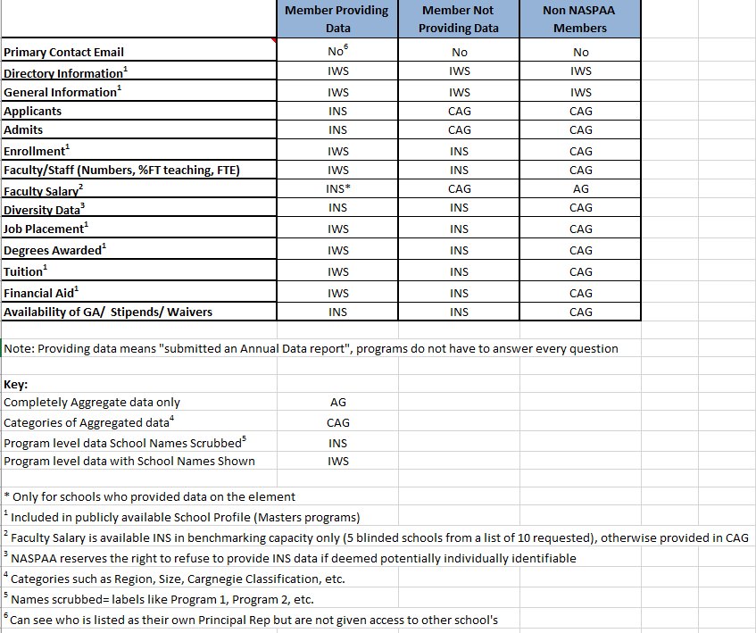

Integrity and Accuracy

The school has the principle responsibility to ensure data submitted and maintained in the Data Center is accurate. NASPAA will use reasonable efforts to ensure that data distributed is not corrupted while stored in the Data Center.

The Data Policy Committee, in consultation with staff, will define accuracy standards for data and may perform data integrity verification and testing routines at its discretion. Minimum accuracy standards will be defined for difficult to collect areas. Each school must use best efforts to meet these accuracy standards. Schools are permitted to access their data and request changes to correct inaccuracies, both on behalf of the school and their data subjects.

NASPAA may refuse to release data whose integrity does not meet data quality standards, as it has the potential to mislead. NASPAA will not release aggregate data publicly until minimum acceptable participation rates are reached. This may apply to individual data elements as well as aggregate data. This will not affect NASPAA providing APPAM its members’ data as stipulated in our MOU.

It is the obligation of each school to respond to NASPAA data integrity inquiries. Schools will be sanctioned for failure to adequately respond to data integrity issues.

Privacy and Security

All use of NASPAA data will follow FERPA guidelines in order to ensure privacy (aggregating student data without any individual identification). NASPAA will not release data which identify individuals, in order to protect privacy, with the exception of directory information for member programs’ employees or representatives.
NASPAA will maintain appropriate technology systems to ensure compliance with federal legal requirements for student data. NASPAA technology systems will be able to provide authenticated selected access to data elements in order to implement this data policy.

NASPAA Faculty Salary Data Memo
Draft 2/3/2015
Submitted by: Stacy Drudy, Data Center Director
One of the most sensitive data elements NASPAA collects is salary data; both the faculty salary data we collect currently and the alumni salary data we will be collecting in the upcoming Common Alumni Survey. Salary data will allow NASPAA to make important comparisons between ourselves and competing fields such as business administration. The main concerns regarding salary data are ensuring NASPAA stays within the Federal Trade Commission’s (FTC) antitrust regulations and preserves individual data privacy. This memo looks at the laws governing salary data, an example of how one of our peer organizations (AACSB) addresses the issue, and provides a recommendation for NASPAA moving forward.
The law governing the collection of salary data is the Sherman Antitrust Act of 1890, in which its “provisions on pricing and competition… impact those seeking information on compensation practices via salary surveys...[due to the fact the Department of Justice (DOJ) and FTC] have determined that organizations conducting their own salary surveys could be seen as practicing illegal price-fixing”.
Faculty Salary
The first way in which NASPAA has worked to mitigate antitrust concerns and to protect individual faculty salary data is to simply not ask for individual faculty salary data. Instead NASPAA asks member schools to provide the median salary for each position (Professor, Associate Professor, and Assistant Professor). In any member school where there are fewer than 3 faculty members, or in which they feel the data they have would be individually identifiable, we have asked those schools to provide the median salary for their full faculty not broken out by position.
To assist those collecting salary data the DOJ/ FTC have created a set of “Safety Zone Statements” to provide guidelines for those seeking to collect salary data within the boundaries of the law. Those statements are:
“Antitrust Safety Zone: Exchanges of Price and Cost Information Among Providers That Will Not Be Challenged, Absent Extraordinary Circumstances, By The Agencies
The Agencies will not challenge, absent extraordinary circumstances, provider participation in written surveys of (a) prices for health care services, or (b) wages, salaries, or benefits of health care personnel, if the following conditions are satisfied:
- The survey is managed by a third-party (e.g., a purchaser, government agency, health care consultant, academic institution, or trade association);
- The information provided by survey participants is based on data more than 3 months old; and
- There are at least five providers reporting data upon which each disseminated statistic is based, no individual provider's data represents more than 25% on a weighted basis of that statistic, and any information disseminated is sufficiently aggregated such that it would not allow recipients to identify the prices charged or compensation paid by any particular provider.”
Given these guidelines, NASPAA easily meets the first two conditions, both by being a third party managing the survey and collecting data in the following Academic Year. The third guideline will pertain more to how NASPAA releases the data rather than how it is collected. Given the past two Annual Data Reports, on average about 105 schools have reported on faculty data (almost 40% of members); therefore we will easily reach the five providers threshold. However, depending on how NASPAA chooses to release the data the five provider threshold may become an issue.
There are a few of ways in which NASPAA could release salary data:
- Only in the aggregate
- Broken out by aggregated categories, such as Carnegie Classification, Region, R Level (School Size), etc.
- Benchmarking

AACSB
AACSB unlike NASPAA does collect their faculty salary information at the individually identifiable level and collects a number of demographic type data along with it to be able to break the salary data into a number of categories. In speaking with my counterpart at AACSB, he made it clear that the main way in which AACSB deals with Data privacy laws is to ensure they ask their questions in a way in which the data they receive complies with regulations.
The main way that AACSB takes in complying with antitrust regulations is to prohibit schools from attaching faculty names with the individual salary data they are collecting. Due to this fact the main issue for AACSB along with NASPAA is in the release of the data rather than how it is collected.
AACSB releases data in the following ways:
- Overview report available to the public (Executive Summary)
- Overview Aggregate report for members who participated in the survey
- Released within their database for benchmarking use (participating members only)
The release of the salary data through benchmarking is the biggest area of concern in ensuring data privacy. AACSB always releases salary data in aggregate, however they do allow participating members to create “peer groups” in which they can compare their school with at least 6 other schools. The data from the 6 other schools is aggregated and the school can compare their data with the aggregated data from the peer group they have chosen. Schools may create as many peer groups as they wish. However, to ensure the school’s data isn’t individually identifiable each peer group must be different from the others by three schools.
Recommendation
It is my recommendation that NASPAA adopts a similar method for releasing salary data as AACSB does. NASPAA should only be providing salary data to those schools who have provided it. NASPAA should provide the aggregate data to the public, with in depth analysis and data broken out by aggregate categories available to members who have participated not only in the data survey but have provided salary data. NASPAA should in the development of its benchmarking tool, adopt a similar policy of aggregating data from a set number of schools to a peer group, restricting overlap to prevent individually identifiable school data. The main difference I would recommend from AACSB’s current policy is to be stricter with regards to data released by category, holding to the guideline of five providers rather than the three providers used by AACSB.

NASPAA will provide APPAM its data as per our MOU
http://compforce.typepad.com/compensation_force/2007/02/antitrust_regul.html (accessed 1/20/15).
Schools with multiple degrees offered aggregate the data by school and do not break it out by degree
See attached example
They allow schools to attach a number ID so they can track faculty overtime if they wish.
For any data element/category where there are fewer than 3 respondents system automatically hides
While aggregate also broken out by categories (rank, field, tenure track, new hires etc)

